12.Develop a system using UML for Foreign Trading System, to maintain the details about the trading system that exists between the two countries. These details are to be held by the trading management system. The supplier and the customer will interact with the system.

USE-CASE DIAGRAM

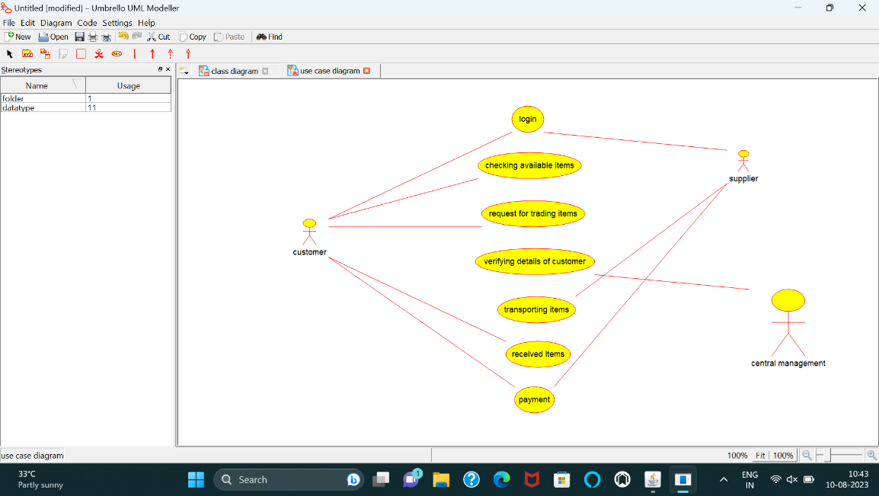

SEQUENCE DIAGRAM

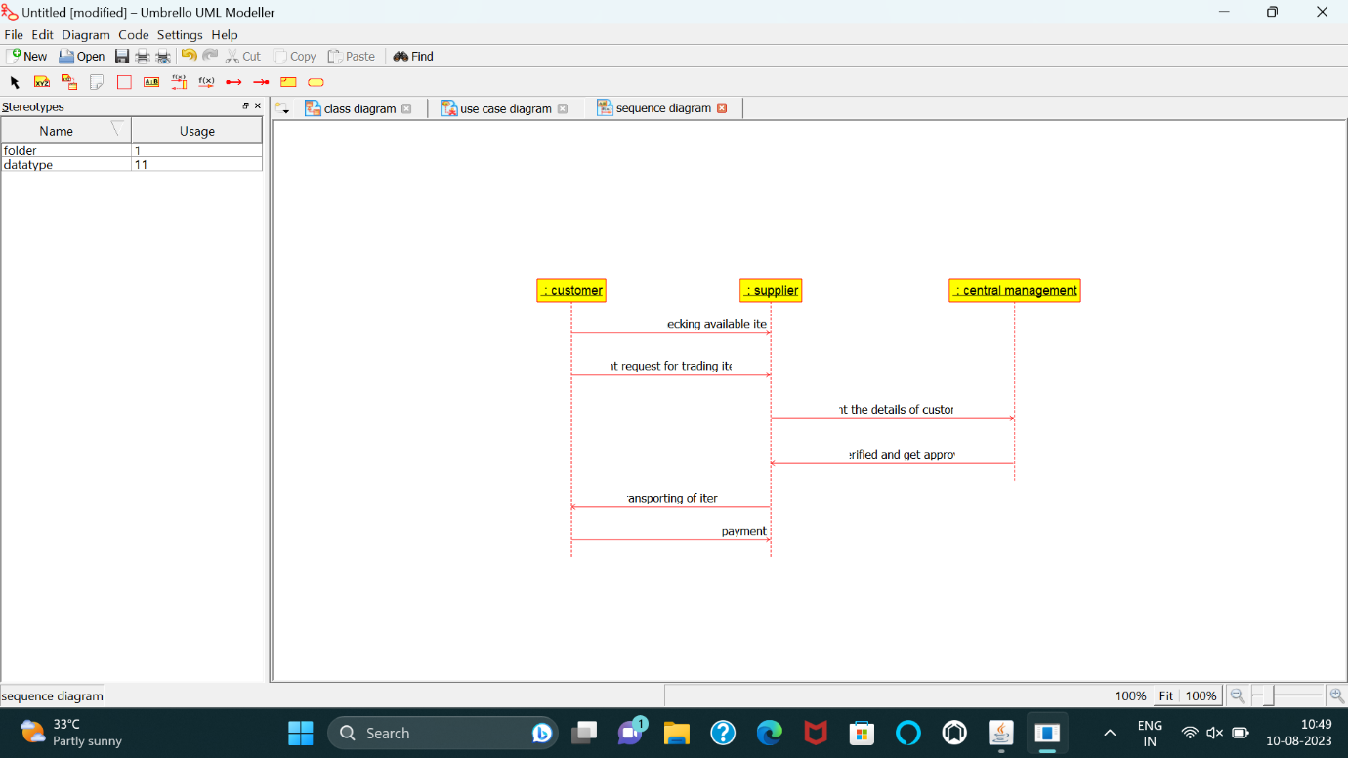

COMPONENT DIAGRAM

